PROGRAMME: BCA (Bachelor of Computer Applications)
COMMON
SEMESTER – I

Teaching-Learning & Evaluation Plan

Course Information:

Course Code: 25BCA1C04L Course Title: Problem Solving Techniques LAB
Credits Units: 01 Contact Hours: 30 L-T-P-E: 0-0-2-0
CA Weightage - 100 Pass Marks (CA) – 40 Special Examination Fees: NA
Course Facilitator (s): Prof. Jayashree M K, Prof. Sushma B S, Prof. Sonali K, Prof. Bhavani, Prof. Prathima, Prof. Dilchashmi, Prof. Adlin Jebakumari

Programme Outcomes (POs)
At the end of the programme, students will be able to
PO 1 | Foundation Knowledge: Apply mathematical concepts and programming fundamentals to develop solutions for IT systems and applications.
PO 2 | Problem Analysis: Analyze and interpret IT requirements to identify, formulate, and solve computational problems using standard practices.
PO 3 | Design Development of Solutions: Design and develop IT solutions, including software and applications, to address real-world challenges.
PO 4 | Modern Tool Usage: Use modern Computing tools and techniques necessary for innovative technological solutions.
PO 5 | Individual and Teamwork: Work effectively both as an individual and as part of a team in multidisciplinary IT projects.
PO 6 | Project Management: Apply project management principles and agile methodologies to plan, schedule, and execute IT projects.
PO 7 | Ethics and Social Responsibility: Demonstrate ethical practices in IT solutions, including data privacy, cybersecurity, and sustainable development.
PO 8 | Life-long Learning: Engage in continuous learning through certifications, workshops, and industry-relevant training to adapt to emerging technologies.
PO 9 | Entrepreneurship and Innovation: Demonstrate innovation and entrepreneurial skills by identifying opportunities to create IT solutions for business and societal needs.

Programme Educational Objectives (PEOs)
PEO 1 | Technical Proficiency and Problem-Solving: Demonstrate expertise in solving complex problems using modern computing tools.
PEO 2 | Lifelong Learning and Adaptability: Engage in lifelong learning to adapt to technological advancements.
PEO 3 | Ethical and Responsible Leadership: Exhibit ethical behavior and contribute to sustainable development.
PEO 4 | Effective Communication and Teamwork: Demonstrate strong communication skills and teamwork.
PEO 5 | Research and Innovation: Pursue research and entrepreneurial ventures in computing technologies.

Course Objectives (COB’s)
COB1 | To understand the problem solving techniques and methodologies which are essential to solve a given problem
COB2 | To practice the fundamental programming methodologies in the C programming language via laboratory experiences
COB3 | To code, document, debug, and implement a well-structured, reusable, robust computer program using the C programming language

Course Outcomes:
At the end of the course, students will be able to

Sl. No. | Course Outcome | Description | Bloom’s Taxonomy Level
1. | CO1 | Create program to solve given problem using control flow and loop | BL6
2. | CO2 | Write program to create arrays and perform various operations on it | BL6
3. | CO3 | Construct program to solve given problem using modular techniques like functions and pointers | BL6
4. | CO4 | Write program to perform various string operations | BL6
5. | CO5 | Develop program using structure and union | BL6

CO-PO/PSO Mapping: (3-Strong Correlation 2- Medium Correlation 1- Low Correlation)

Course Outcome | Bloom's Taxonomy Levels | Program Outcomes (PO’s)  Mapped
 |  | PO1 | PO2 | PO3 | PO4 | PO5 | PO6 | PO7 | PO8 | PO9
CO1 | BL6 | 3 | 3 | 3 | 1 | 2 | - | - | 2 | -
CO2 | BL6 | 3 | 3 | 3 | 2 | 2 | - | - | 2 | -
CO3 | BL6 | 3 | 3 | 3 | 2 | 2 | - | - | 2 | -
CO4 | BL6 | 3 | 2 | 3 | 2 | 2 | - | - | - | -
CO5 | BL6 | 3 | 2 | 3 | 2 | 2 | - | - | - | -
Average |  | 3 | 2.6 | 3 | 1.8 | 2 | - | - | 2 | -

Syllabus
Experiment No | Name of the Experiment | Marks | CO
Experiment 1 | - Converting degrees Celsius to Fahrenheit and vice versa  - Compute character grade from marks (using else-if ladder and switch case) | 25 | CO1
Experiment 2 | - Given a positive integer value n (>= 0) display number, square and cube of numbers from 1 to n in a tabular format  - Display the first n terms of Fibonacci sequence | 25 | CO1
Experiment 3 | - Extract digits of an integer (left to right and right to left)  - Check if a given number is a palindrome | 25 | CO1
Experiment 4 | - Check if a number is a perfect number  - Check if a number is an Armstrong number | 25 | CO1
Experiment 5 | - Design a program to compute the median of an array  - Recursive function to compute factorial of a number  - Generate N Fibonacci numbers using a recursive function | 25 | CO2, CO3
Experiment 6 | - Compute maximum, minimum, sum, and average of a sequence of numbers  - Perform matrix operations (Addition, Subtraction, Transpose) | 25 | CO2, CO3
Experiment 7 | - Display three input numbers in sorted (non-decreasing) order (Bubble Sort)  - Search a given element in an array of elements | 25 | CO2, CO3
Experiment 8 | - To swap the values of two variables using pointers.  - To find the area and circumference of a circle using pointers and functions. | 25 | CO3
Experiment 9 | - Print the length of a given string.  - Concatenate two strings using the string handling function | 25 | CO1, CO4
Experiment 10 | - To create and use a structure for student data.  - To create and use a structure for an employee data  - To create and use a Union for Car data. | 25 | CO1, CO5

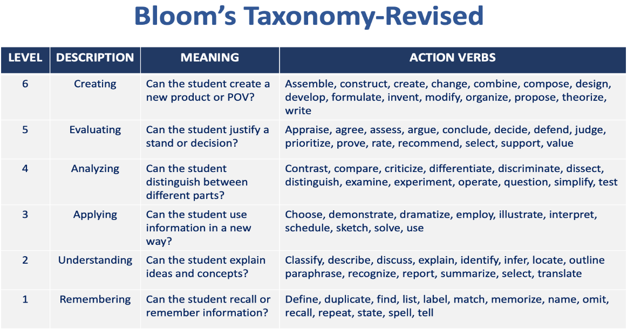

Signature of the Faculty Signature of the HoD

